**Homework 1 – Nathan Guenther**

1. Word Count

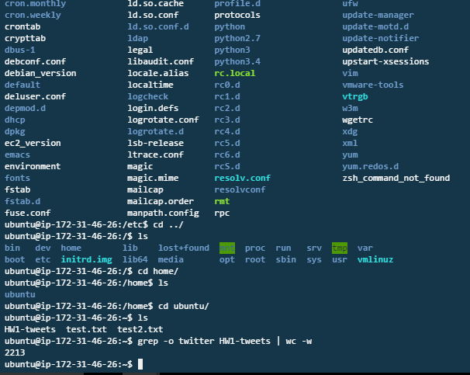

1. Available Disk Space

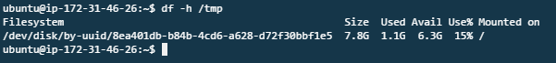

1. IP Address
   * *Note this is internal IP for AWS EC2 instance. Public IP is listed within the dashboard, but to this VM it is hidden behind amazon’s network.
   * **Public IP:** 54.68.253.71



1. Hostname
   * *Note this is internal hostname for this AWS EC2 instance. Public Hostname is listed within the dashboard, but to this VM it is hidden behind amazon’s network.
   * **Public DNS**: ec2-54-68-253-71.us-west-2.compute.amazonaws.com

